Day 4 - Attribute - scr - href
- image
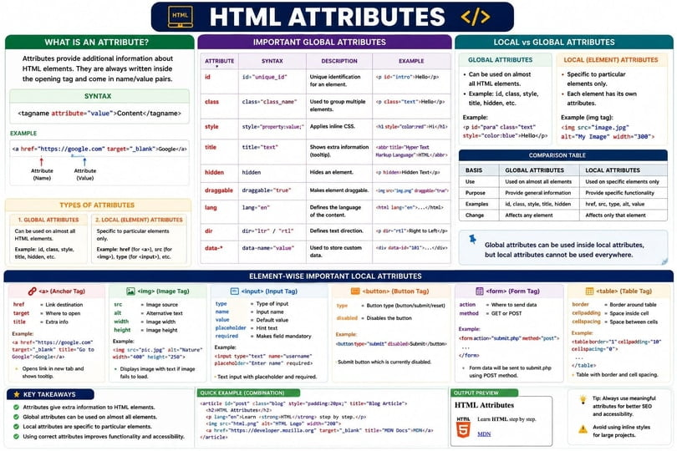
- Text
  - Fullscreen
HTML Attributes - Detailed Notes
What is an Attribute?
An Attribute provides additional information about an HTML element.
Attributes are always written inside the opening tag.
Syntax
<tagname attribute="value">
Content
</tagname>
Example
<a href="https://google.com">
Google
</a>
Here:
href = Attribute Name

https://google.com = Attribute Value

Structure of an Attribute
<img src="image.jpg" alt="Student Image">
Breakdown:
src → Attribute Name

image.jpg → Attribute Value

alt → Attribute Name

Student Image → Attribute Value

Why Do We Use Attributes?
Attributes provide extra information to HTML elements.
Without Attributes:
<img>
Browser doesn't know:
Which image?
Where is the image?
With Attributes:
<img src="student.jpg">
Browser knows which image to display.

Types of Attributes
HTML Attributes are mainly divided into:
1. Global Attributes
2. Local (Element Specific) Attributes

1. Global Attributes
Global Attributes can be used on almost every HTML element.
Example
<h1 id="heading" class="title">
HTML
</h1>

Important Global Attributes
id Attribute
Used to uniquely identify an element.
<h1 id="main-heading">
Welcome
</h1>
Rules
  - Must be unique.
  - One page should not contain duplicate ids.

class Attribute
Used to group multiple elements.
<p class="content">
HTML
</p>

<p class="content">
CSS
</p>
Purpose:
  - CSS Styling
  - JavaScript Selection

title Attribute
Displays tooltip information.
<p title="Hyper Text Markup Language">
HTML
</p>
When user hovers over HTML, tooltip appears.

style Attribute
Used for inline CSS.
<h1 style="color:red;">
HTML
</h1>

hidden Attribute
Hides an element.
<p hidden>
Secret Content
</p>

draggable Attribute
Allows dragging.
<img src="html.png" draggable="true">

lang Attribute
Specifies document language.
<html lang="en">

Local Attributes
Local Attributes work only on specific elements.

Anchor Tag Attributes
href
Specifies destination URL.
<a href="https://google.com">
Google
</a>

target
Specifies where to open the link.
<a href="https://google.com"
target="_blank">
Google
</a>
Output:
Opens in a new tab

download
Downloads the file.
<a href="resume.pdf" download>
Download Resume
</a>

Image Tag Attributes
src
Specifies image location.
<img src="student.jpg">

alt
Alternative text.
<img src="student.jpg"
alt="Student Photo">

width
Sets image width.
<img src="student.jpg"
width="300">

height
Sets image height.
<img src="student.jpg"
height="200">

Input Tag Attributes
type
Specifies input type.
<input type="text">
Examples:
<input type="email">
<input type="password">
<input type="number">
<input type="date">
<input type="file">

placeholder
Displays hint text.
<input
type="text"
placeholder="Enter Name">

required
Makes field mandatory.
<input
type="email"
required>

value
Provides default value.
<input
type="text"
value="Sudhan">

readonly
User cannot edit value.
<input
type="text"
value="HTML"
readonly>

disabled
Disables input field.
<input
type="text"
disabled>

Form Tag Attributes
action
Specifies where form data goes.
<form action="register.php">
</form>

method
Specifies HTTP method.
<form method="post">
</form>
Values:
GET
POST

Table Attributes
border
Adds border.
<table border="1">
</table>

cellpadding
Space inside cells.
<table cellpadding="10">
</table>

cellspacing
Space between cells.
<table cellspacing="5">
</table>

Most Important Beginner Attributes
id
class
title
style
href
target
src
alt
width
height
type
placeholder
required
value
readonly
disabled
action
method

Example Using Multiple Attributes
<a
href="https://google.com"
target="_blank"
title="Open Google">
Google
</a>

<img
src="student.jpg"
alt="Student Photo"
width="300"
height="200">

<input
type="text"
placeholder="Enter Name"
required>

Difference Between Global and Local Attributes
Global Attributes | Local Attributes
Work on almost all elements | Work on specific elements
id | href
class | src
style | alt
title | target
hidden | type

